1 Walkthrough 36 Device Adaptation

https://sapui5.hana.ondemand.com/#/topic/d63a15e5eebb45cdada317bae5f45bc2



2 Core Changed Codes Compared to Last Version:

2.1 Component.js 加载SAPUI5-Device

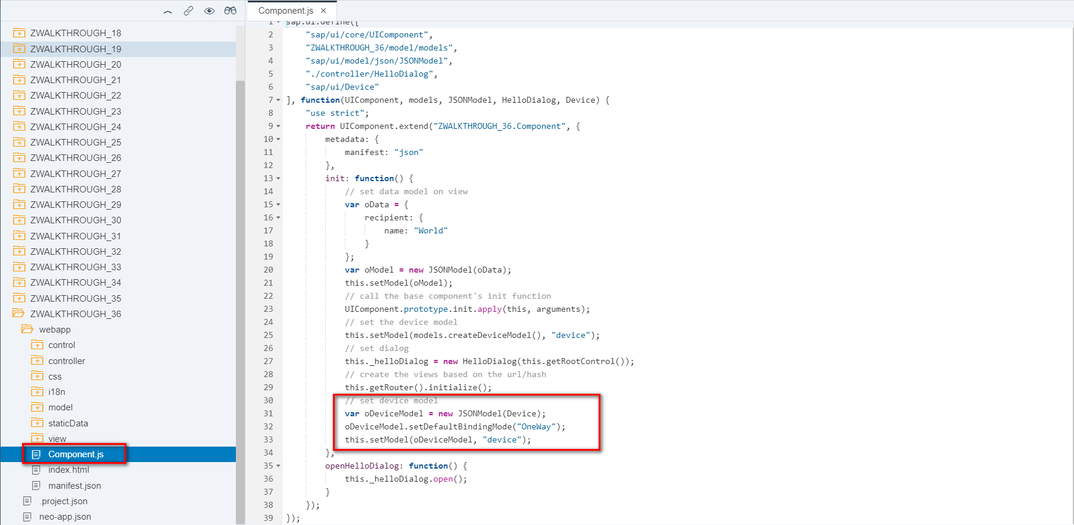

2.2 HelloPanel.view.xml

绑定Device数据模型:当设备为手机时,设置Panel为不可展开;

Say Hello With Dialog按钮指定样式:仅当PC设备时显示;

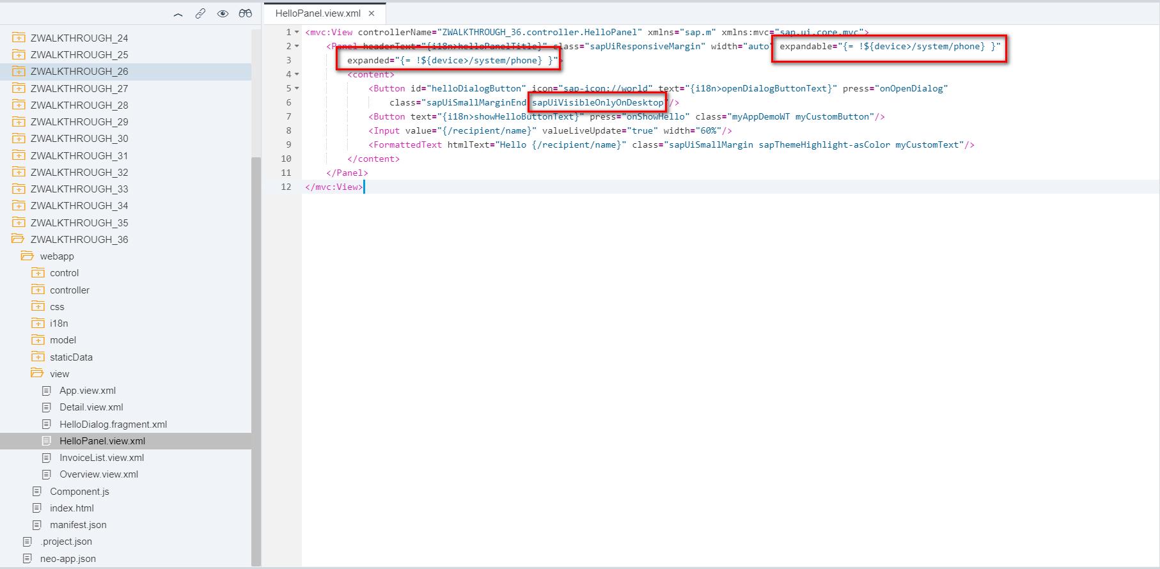

2.3 Detail.view.xml 部分UI空间自身支持设备自适应

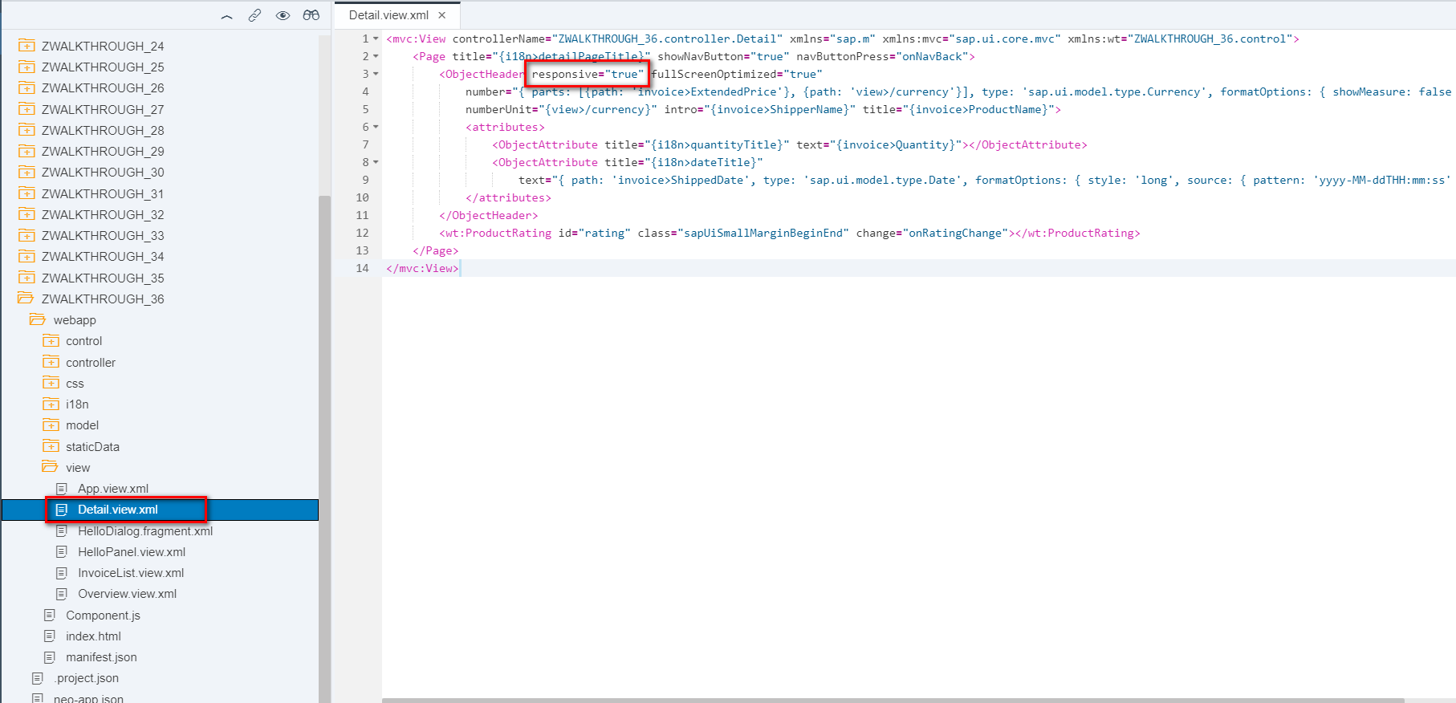

2.4 Detail.controller.js

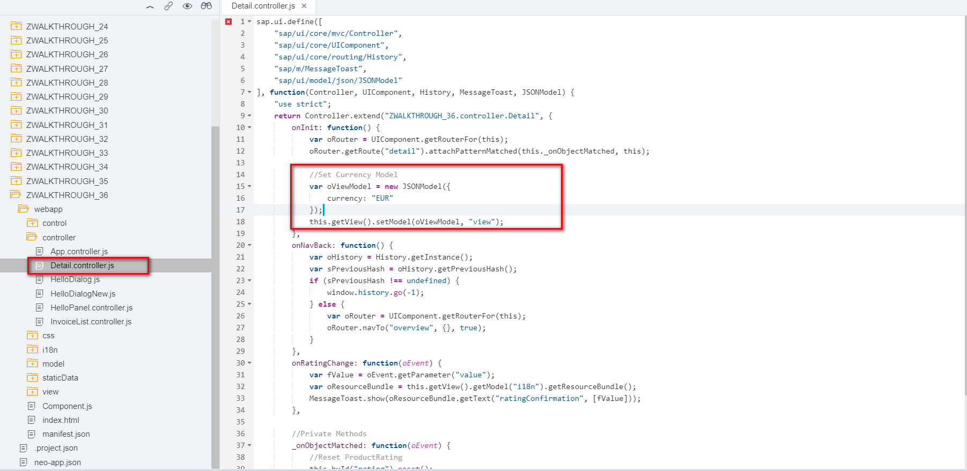

2.5 i18n 统一文本对象管理

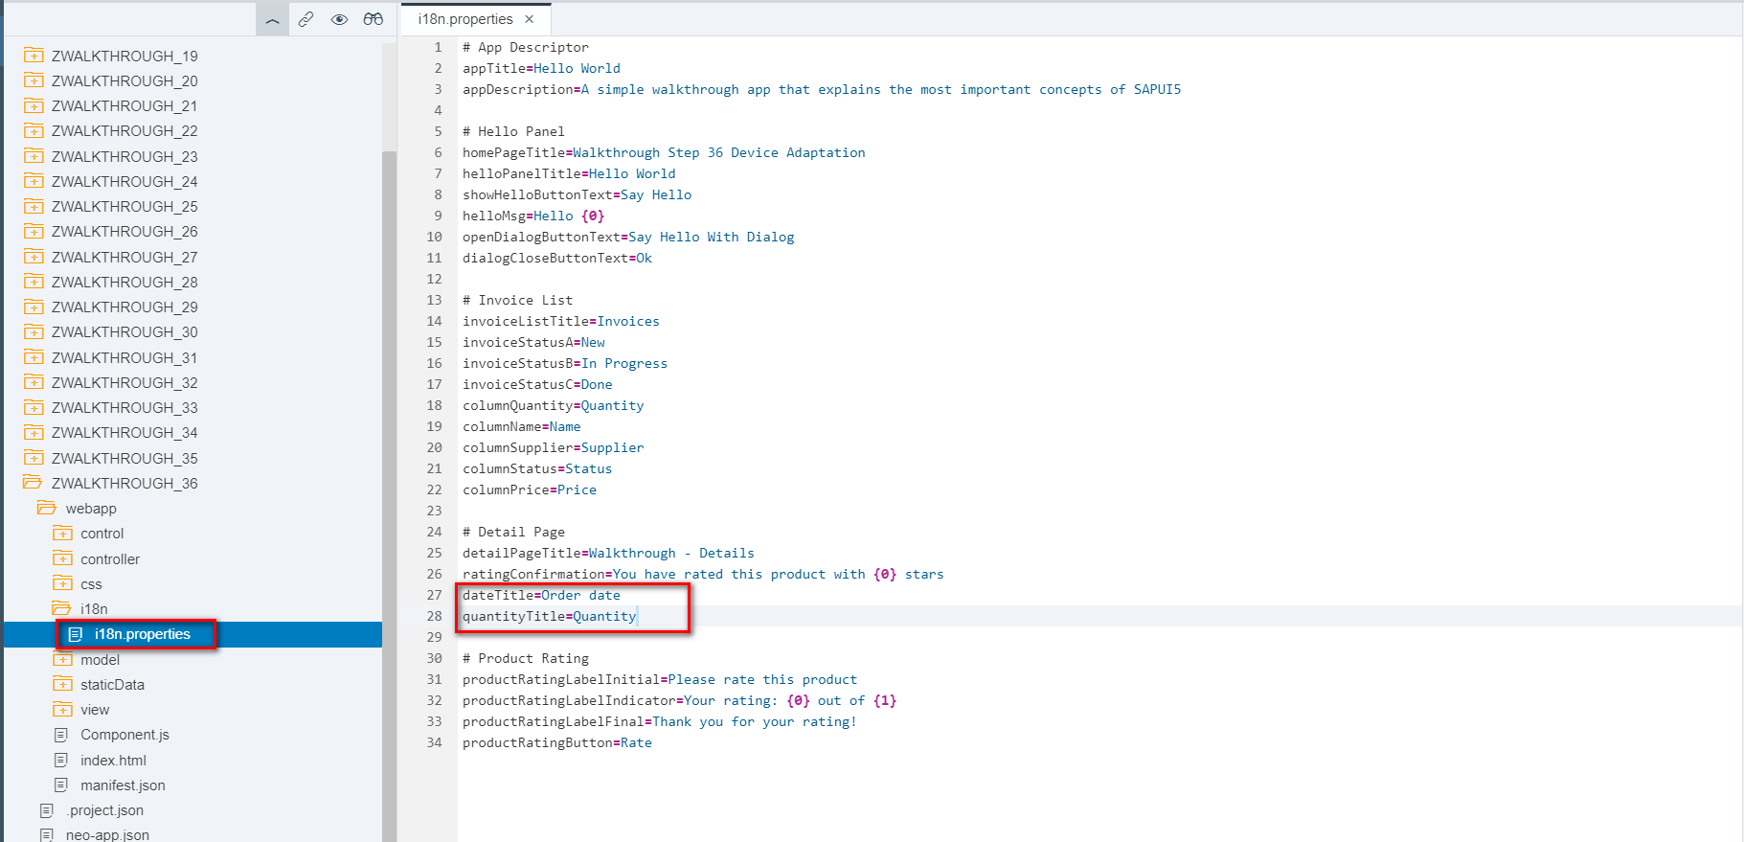

3 Result

PC

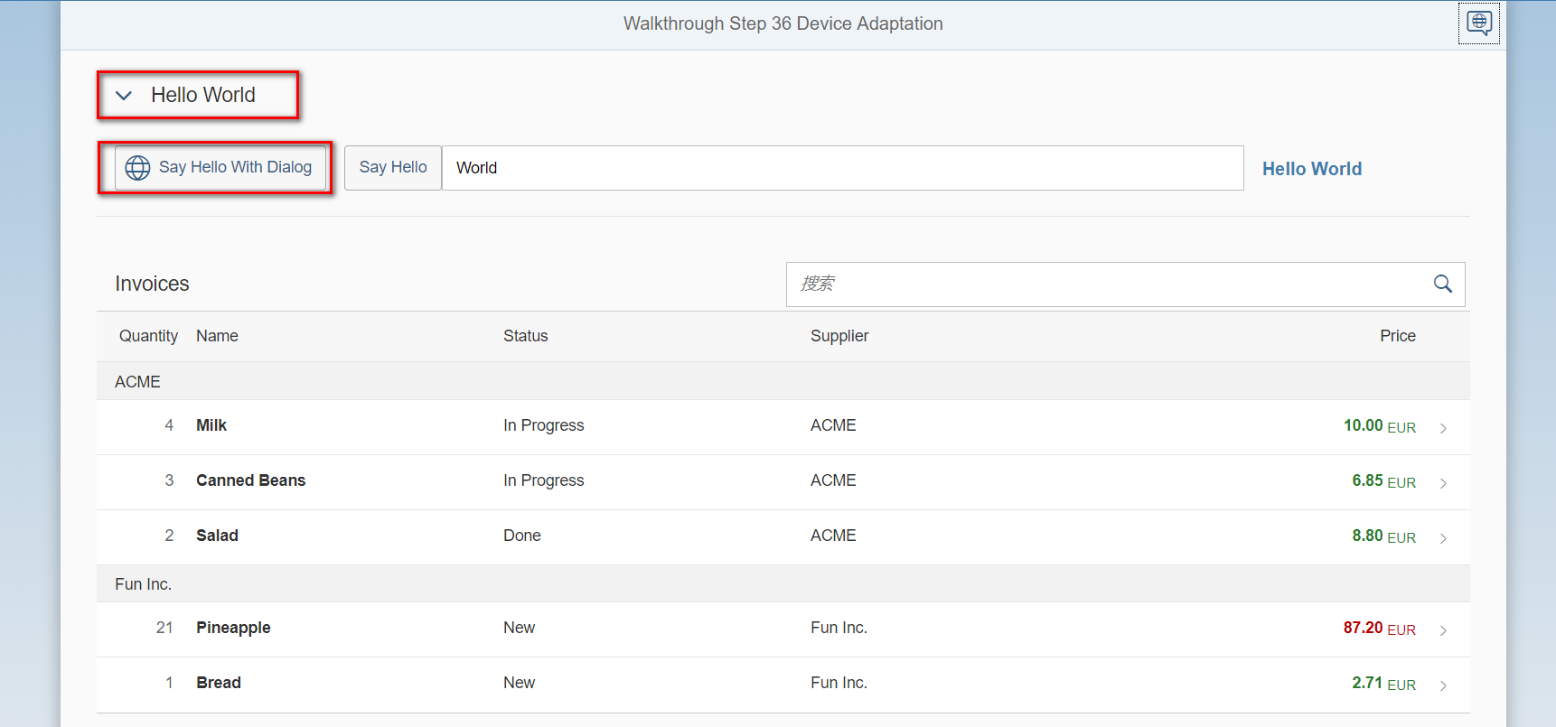

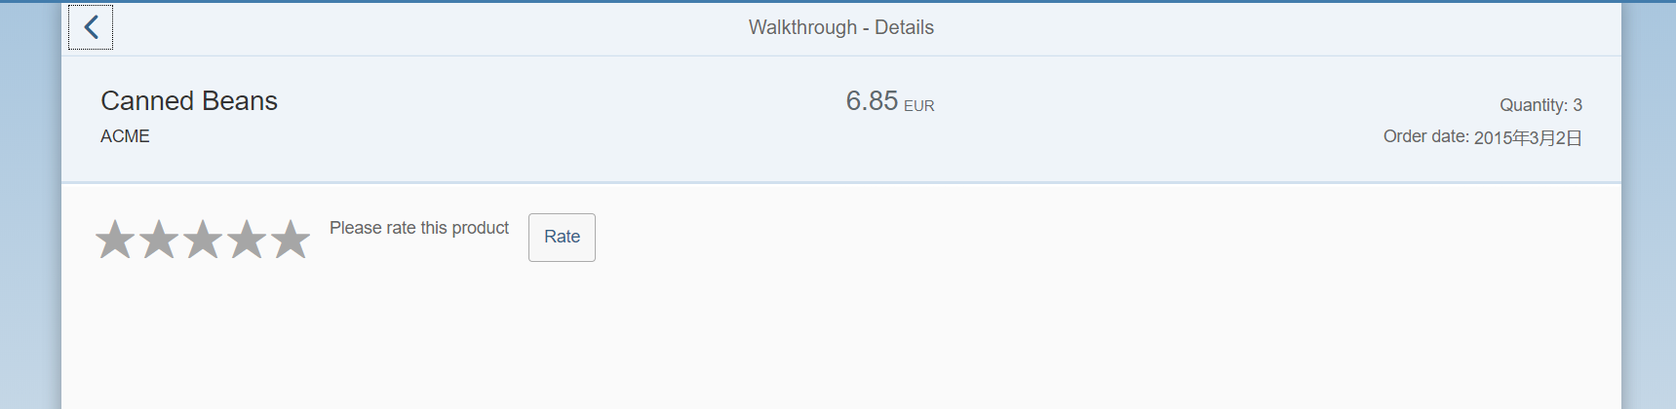

手机

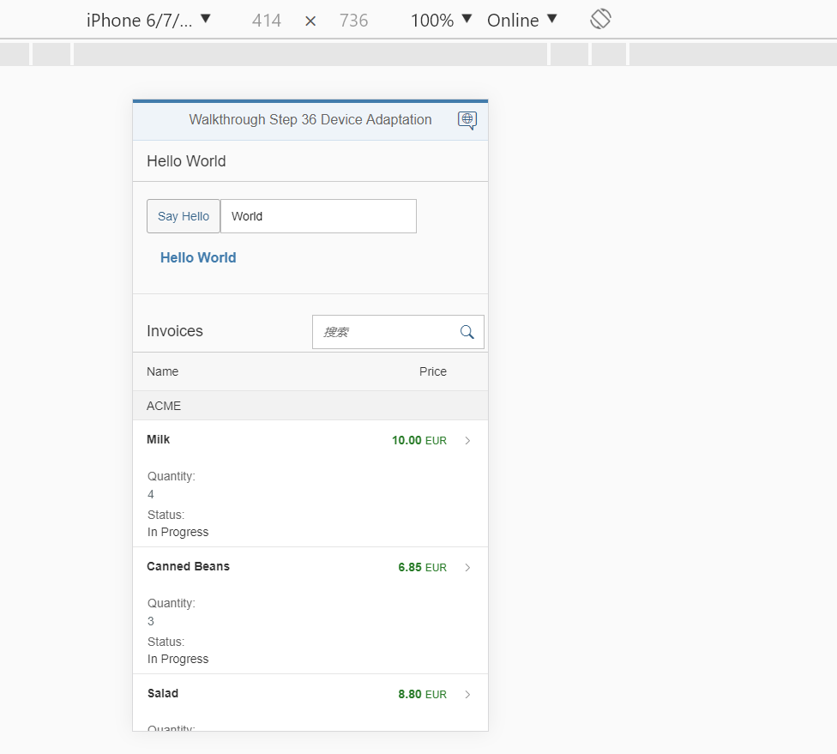

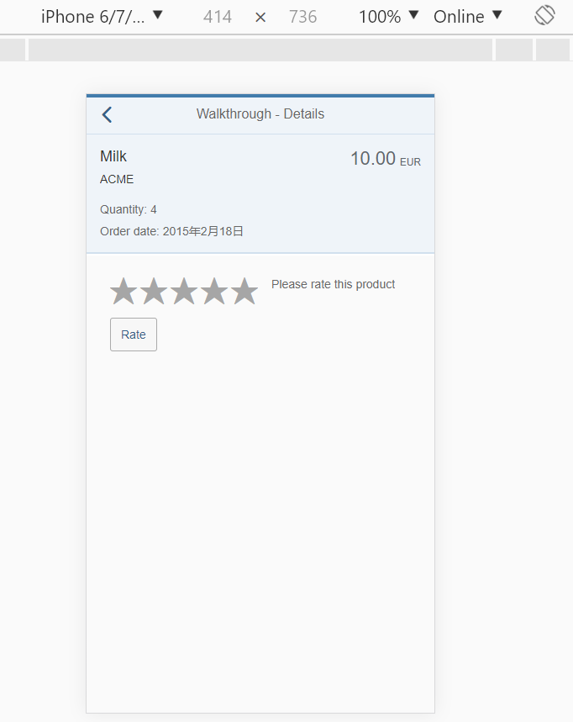

4 Git:

https://github.com/xiexiaop/SAPUI5-2-Round/tree/master/Projects/ZWALKTHROUGH_36

2019/02/08 XiaoMi Beijing Zac,Xie